Elements of the theory of experiment planning

The mathematical theory of the experiment determines the conditions for optimal research, including with incomplete knowledge of the physical essence of the phenomenon. To do this, mathematical methods are used in the preparation and conduct of experiments, which allows you to investigate and optimize complex systems and processes, ensure high efficiency of the experiment and accurate determination of the investigated factors.
Experiments are usually staged in small series using a pre-agreed algorithm. After each small series of experiments, the results of observations are processed and a strictly justified decision is made on what to do next.
Using the methods of mathematical planning of the experiment, it is possible:
• Solve various issues related to the study of complex processes and phenomena;
• - conduct an experiment in order to adapt the technological process to changing optimal conditions of its course and thus ensure high efficiency of its implementation, etc.
The theory of mathematical experiment contains a number of concepts that ensure the successful implementation of research tasks:
• - the concept of randomization (procedure for random selection of elements of the statistical population when conducting a sample study);
• - concept of a sequential experiment;
• - concept of mathematical modeling;
• - the concept of optimal use of factor space and a number of others.
The principle of randomization is that an element of randomness is introduced into the experiment plan. To do this, the experiment plan is designed so that those systematic factors that are difficult to control are considered statistically and then excluded in studies as systematic errors.
In a sequential process, the experiment is carried out in stages rather than simultaneously, so that the results of each stage are analysed and further studies are considered appropriate (Figure 8.1). As a result of the experiment, a regression equation is obtained, which is often called a process model.
For specific cases, the mathematical model is created based on the target focus of the process and research tasks, taking into account the required accuracy of the solution and the reliability of the initial data.
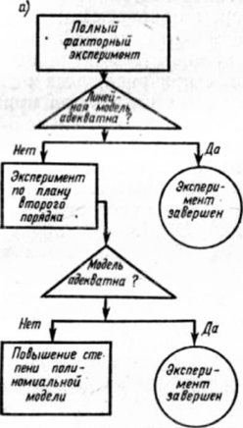

Risunok8.1. Structural diagram of the experiment:
• a) - for the purpose of mathematical description of the investigated process;
• b) - in order to optimize the investigated process
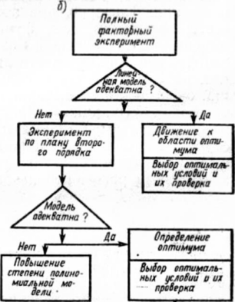
Catalogues of pilot plans have now been published, providing a comparative assessment of the plans and recommendations for their selection in relation to the specific conditions of the experiment.
An important place in the theory of experimental planning is occupied by the optimization of the investigated processes, the properties of multi-component systems or other objects.
Typically, one cannot find a combination of influencer values that simultaneously reaches the extreme of all response functions. Therefore, in most cases, only one of the state variables is chosen as the optimality criterion, the response function characterizing the process, and the rest are accepted as acceptable for this case.
Methods of planning the experiment are now rapidly developing, which is facilitated by the possibility of widespread use of computers.
A computational experiment is a methodology and research technology based on the application of applied mathematics and electronic computing machines as a technical base when using mathematical models.
In general, the computational experiment is based on the creation of mathematical models of the studied objects, which are formed using a certain special mathematical structure that can reflect the properties of the object that it manifests under various experimental conditions.
However, these mathematical structures turn into models only when the elements of the structure are given a physical interpretation, when the relationship between the parameters of the mathematical structure and experimentally defined properties of the object is established, when the characteristics of the elements of the model and the model as a whole find compliance with the properties of the object.
Thus, mathematical structures, together with a description of correspondence to experimentally discovered properties of an object, are a model of the studied object, reflecting in mathematical, symbolic (symbolic) form the dependencies, connections and laws that objectively exist in nature.
Each computational experiment is based both on a mathematical model and on the techniques of computational mathematics. Modern computational mathematics consists of many sections developing along with the development of electronic computing.
On the basis of mathematical modeling and methods of computational mathematics, the theory and practice of a computational experiment was created, the technological cycle of which is usually divided into the following stages.
1. For the object under study, a model is built, usually first physical, fixing the division of all factors acting and the phenomenon under consideration into main and secondary ones, which are discarded at this stage of the study.
At the same time, assumptions and conditions for the applicability of the model are formulated, boundaries in which the results will be fair. The model is written in mathematical terms, as a rule, in the form of differential or integrodif-ferential equations.
2. A method of calculating a formulated mathematical problem is being developed. This problem is presented in the form of a set of algebraic formulas, according to which calculations and conditions must be carried out that show the sequence of application of these formulas; the set of these formulas and conditions is called a computational algorithm.
The computational experiment has a multivariable character, since the solutions to the tasks set often depend on numerous input parameters. However, each particular calculation in the computational experiment is carried out at fixed values ​ ​ of all parameters.
Meanwhile, as a result of such an experiment, the task of determining the optimal set of parameters is often set. Therefore, when creating an optimal installation, you have to conduct a large number of calculations of the same type of task, which differ in the value of some parameters. In this regard, effective numerical methods can be used in organizing a computational experiment.
• 3. An algorithm and program for solving the problem on a computer are being developed. Decision programming is now determined not only by the art and experience of the performer, but develops into independent science with its fundamental approaches.
• 4. Computer-based calculations. The result is obtained in the form of some digital information, which will further need to be decrypted. The accuracy of the information is determined during a computational experiment by the validity of the model underlying the experiment, the correctness of algorithms and programs (preliminary "test" tests are carried out).
• 5. Processing of calculation results, their analysis and conclusions. At this stage, it may be necessary to refine the mathematical model (complication or, conversely, simplification), proposals for creating simplified engineering solutions and formulas that allow you to obtain the necessary information in a simpler way.
The computational experiment takes on exceptional importance in cases where full-scale experiments and the construction of a physical model are impossible.
In science and technology, many areas are known in which a computational experiment is the only possible in the study of complex systems.

